Stream Report Summer 2017

Methods
Data was collected in the field each month beginning in July 2015 at () sites in Walla Walla, Washington. Sites were located at the source (beginning) and mouth (ending) of spring creeks, in Walla Walla and College Place including Butcher Creek, Caldwell Creek, Lassiter Creek, Lincoln Creek, Stone Creek, and Titus Creek. Data was also collected at the source and mouth of Garrison and Yellowhawk creeks, with additional sites added at intervals on Yellowhawk Creek and Whitney Spring Creek in 2016.

Several different types of data were collected including: turbidity, fecal coliform, temperature, pH, conductivity, and dissolved oxygen. This data was collected using a few different instruments. Water samples were collected and analyzed by Walla Walla Regional Water Testing Services for fecal coliform. Temperature data was collected from Onset HOBO temperature data loggers that permanently reside at many of the different sites and collect temperatures continuously at 30-minute intervals. Dissolved oxygen was collected from Onset dissolved oxygen data loggers. Turbidity, pH, conductivity, and dissolved oxygen were collected beginning in April of 2017 at selected sites on Yellowhawk and Whitney Spring Creeks using a Hanna Instruments Probe. In addition, GPS coordinates and photographs were taken at all the sites.

Graphs were generated in and data was analyzed using Microsoft Excel. GIS was used to map coordinates collected by GPS.

Results and Discussion
Temperature:
Spring creeks have an underground origin, so they are not influenced by downstream factors or air climate. Therefore, they are associated with having stable and cool temperatures.

In the creeks that we sampled, spring creeks’ water temperatures were consistently lower at the source of the creek than at the mouth. As shown in graphs 1 and 2, in 2016 every spring creek sampled showed relatively lower and more consistent temperatures at the source compared to the mouth (i.e. Butcher Creek, Caldwell Creek, Lassiter Creek, Lincoln Creek, and Stone Creek).

Garrison and Yellowhawk Creeks are tributary creeks from Mill Creek and flow into the Walla Walla River. In Garrison Creek, the water temperature was higher at the source below its division from Mill Creek than at the mouth. Temperatures ranged between 70 and 80 degrees Fahrenheit from May – June 2016 at the source and between 60 and 70 degrees Fahrenheit from May – June 2016 at the mouth. This discrepancy is because Garrison Creek flows from Mill Creek just after it heats up in the wide shallow flood control channel east of Walla Walla high temperatures. As Garrison Creek flows from its source at Mill Creek to its mouth, several spring creeks intercept it bringing fresh, cool water into it, thus lowering its temperature. Additionally, several miles of riparian restoration have been implemented since 2010 so that most of Garrison Creek is well shaded.

In Yellowhawk Creek, the water temperature was between 60 and 80 degrees Fahrenheit at the source just after its division from Mill Creek in July 2016. As it moves downstream, at Plaza Way the creek was the same temperature as it was at the source. Further downstream, at Yellowhawk’s mouth, the water temperature increased from 70 to 90 degrees Fahrenheit in July 2016. Though riparian restoration has been implemented in over a mile on Yellowhawk Creek there are several reaches where shade is lacking due to urban preferences for lawn or cropland down to the creek. Additional riparian restoration is needed in those areas.

Turbidity:
Along Yellowhawk Creek, the turbidity shows no consistent pattern. It is very low at the source (>5 FNU), higher in the middle at Plaza Way (~20 FNU), and lower again at the mouth (8 – 10 FNU). More research is needed to discern the cause of the turbidity and the particulate matter producing turbidity.

Turbidity readings were also taken at Cottonwood Creek and Russell Creek that are tributaries to Yellowhawk Creek at Plaza Way. Cottonwood Creek and Russell Creek had very low turbidities. Cottonwood Creek’s turbidity was less than 2 FNU and Russell Creek’s turbidity was about 3 FNU. Again, more research is needed to discern why creeks in such closer proximity to Yellowhawk Creek at Plaza way have such different turbidity readings.

Fecal Coliform:

Fecal Coliform readings did not provide an explanation as to why there was no pattern in the turbidity data.

Graph 1: Water temperature in Stone Creek was compared at the source and the mouth. As with other spring creeks, temperature at the source is low and consistent throughout the year, whereas temperature at the mouth varies and reaches relatively high temperatures.

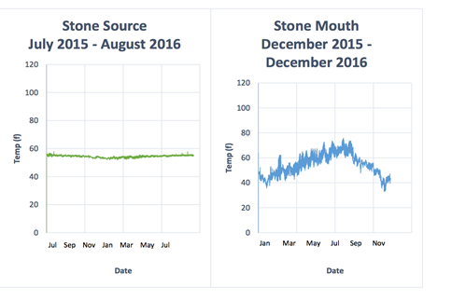

Graph 2: Water temperature along Caldwell Creek was compared at the source and the mouth as well. Similar to with Stone Creek and other spring creeks, temperature at the source is low and consistent throughout the year, whereas temperature at the mouth varies and reaches relatively high temperatures.

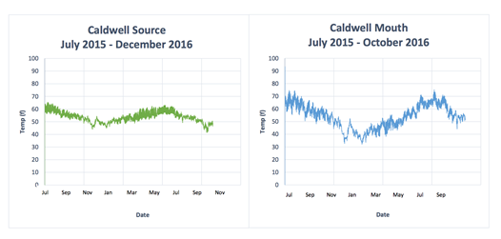

Graph 3: July 2017: At the source of Yellowhawk Creek, the turbidity is low (>5 FNU). The graph also displays temperature, pH, and dissolved oxygen data.

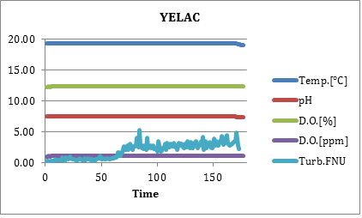

Graph 4: July 2017, In the middle of Yellowhawk Creek (at Plaza Way) the turbidity is higher (~20 FNU).

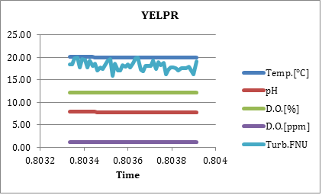

Graph 5: July 2017, At the mouth of Yellowhawk Creek the turbidity is lower again (8 – 10 FNU).

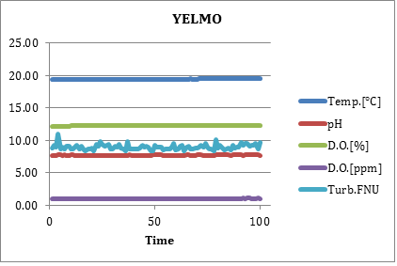

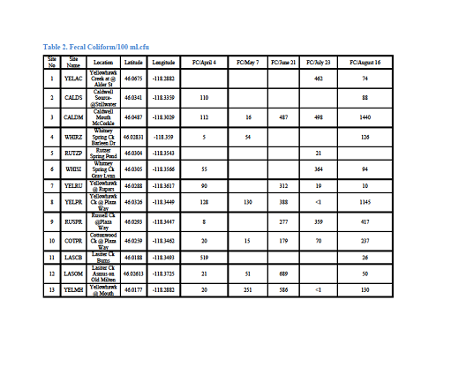

April/May Results:

Table 2. Fecal Coliform-Temperature-Flow
Site No | Site Name | Location | Latitude | Longitude | FC/May 7 |  | Temp/May7 | Temp/ May 21 | Flow/May 7 | Flow/May 21
1 | YELAC | Yellowhawk Creek at @ Alder St | 46.0675 | -118.2882
2 | CALDS | Caldwell Source-@Stillwater | 46.0341 | -118.3359
3 | CALDM | Caldwell Mouth McCorkle | 46.0487 | -118.3029 | 1
4 | WHIRZ | Whitney Spring Ck Rutzer | 46.02831 | -118.359 | 54
5 | RUTZP | Rutzer Spring Pond | 46.0304 | -118.3543
6 | WHISI | Whitney Spring Ck Gray Lynn | 46.0305 | -118.3566
7 | YELRU | Yellowhawk @ Rupars | 46.0288 | -118.3617 |  |  | 11.2 C  52.16 F |  | 1.45 FPS
8 | YELPR | Yellowhawk Ck @ Plaza Way | 46.0326 | -118.3449 | 130 |  | 8.7 C  47.66 F |  | 3.49 FPS
9 | RUSPR | Russell Ck @Plaza Way | 46.0293 | -118.3447 | 7 |  | 9.8 C  49.64 F |  | 1.33 FPS
10 | COTPR | Cottonwood Ck @ Plaza Way | 46.0259 | -118.3462 | 15 |  | 12.2 C  53.96 F |  | 1.98 FPS
11 | LASCB | Lasiter Ck Burns | 46.0188 | -118.3493
12 | LASMO | Lasiter Ck Asmus on Old Milton | 46.02613 | -118.3725 | 51 |  | 11.4C  52.52.F |  | 0.66 FPS
13 | YELMO | Yellowhawk @ Mouth | 46.0177 | -118.2882 | 215 |  | 11.9  53.42 F |  | 2.74 FPS

