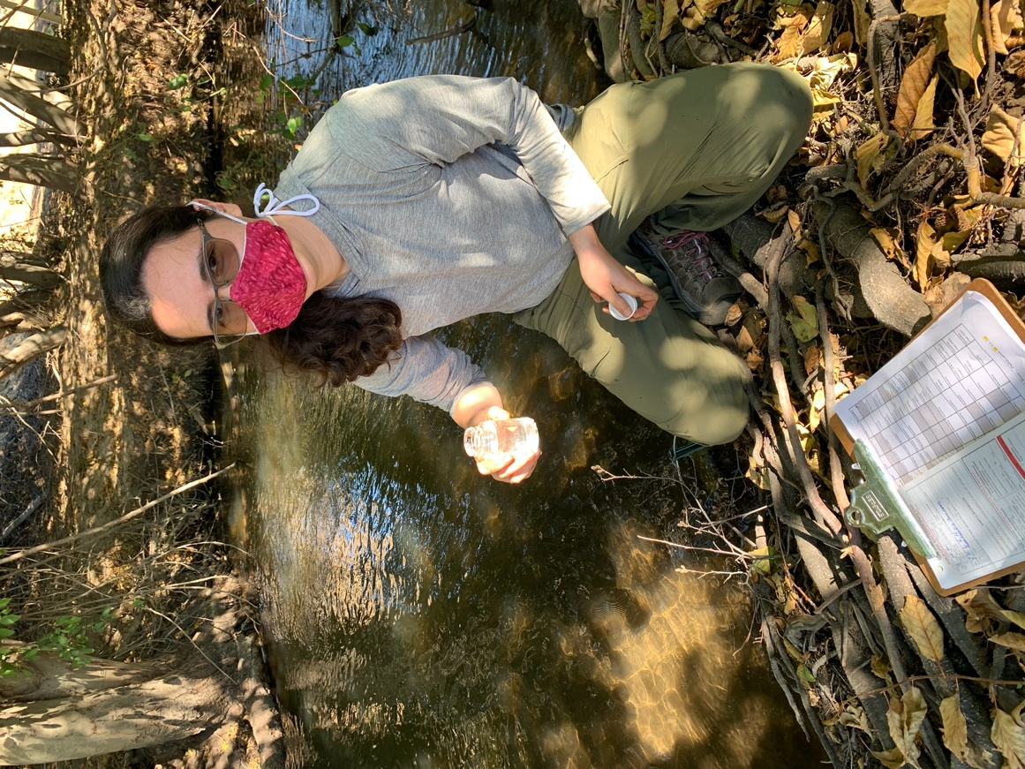

Coming back to an online semester in the fall, I was not expecting to be able to conduct field work, and this was especially disheartening for me as an Environmental Studies - Biology major at Whitman College. I love being outside, especially to gather data and learn about the environment. Fortunately, as the Water Quality Testing Community Fellow with Kooskooskie Commons, I have been able to do just that, all while staying COVID safe. Kooskooskie Commons is a local nonprofit dedicated to restoring and conserving the Walla Walla watershed. We also strive to better understand local environmental conditions and the water requirements of stakeholders and the larger community.
Through a grant from the Washington Department of Ecology, Kooskooskie Commons maintains 18 continuous data loggers placed in streams and rivers across the city, including Mill Creek and the Walla Walla and Yellowhawk rivers. Information from these loggers, such as water temperature and dissolved oxygen levels, provides an insight into the effects of previous stream restoration and the health of the streams at large. Judith Johnson, the leader of the organization, has worked with inmates from the Washington State Penitentiary to restore local streams by removing invasive plants and replacing them with native grasses. Invasive plants can reduce stream flows and increase water temperatures, which harms fish populations.
Every month, we visit each logger, download the data, and make sure everything is working properly. In addition, we collect water samples that are sent to a lab and analyzed further for contaminants such as fecal coliform. The loggers and samples provide critical information that is uploaded to the Department of Ecology and helps to inform the conversations and policies that focus on our watershed.
Although COVID has disrupted the regular in-person meetings focused on water issues that we attend, meetings are still taking place over zoom. Sitting in on these meetings has given me a greater appreciation for just how complicated the issues are. During one meeting run by the Department of Ecology, I was amazed to see over a hundred people coming together from across Washington and Oregon. Seeing so many people gather from across the two states has also helped me to understand the meaning of a watershed and the importance of our work. Yes, the data we collect is important for stakeholders in Walla Walla, but I often forget that it is also pertinent to stakeholders in Oregon, as our water flows down south. The health of our streams, and the work we have done to understand and restore these habitats, has a great impact on other people and communities in the Pacific Northwest.

